**NOTE: This is an official document by Indexademics. Unless otherwise stated, this document may not be accredited to individuals or groups other than the club IDX, nor should this document be distributed, sold, or modified for personal use in any way.**

**IDX G9 (SUBJECT) (LEVEL) STUDY GUIDE ISSUE 5**

**By Hayley and Allison**

7.3 Sizes of Atoms and Ions

Sizes of Atoms:

- The bonding atomic radius is defined as one-half of the distance between covalently bond nuclei.

- Across a period, from left to right, smaller radius

- Atoms’ nuclei gain more proton, increase the effective nuclear charge, which exerts a stronger pull on electrons in the same principle energy level.

- Down a group, larger radius

- Atoms have more principle energy level, which larger orbitals means that the valence electrons are further from the nucleus.

Sizes of Ions:

- Ionic size depends on:

1. nuclear charge
2. number of electron
3. orbitals in which electrons reside

- Cations (positive charge ions) are smaller than their parent atoms

- Outermost electron removed & repulsion reduced

- Antions (negative charge ions) are larger than their parent atoms

- Electron added & repulsion increase

- Ionic size increase down group

- In isoelectronic series, ions with same number of electrons, ionic size decreases with an increasing nuclear charge.

7.4 Ionization

Ionization Energy:

- Amount of energy required to remove an electron (valence electron first) from the ground state of a gaseous state of a gaseous atom or ion (akways positive). (Minimum energy required to remove an electron)

- First ionization energy, second ionization energy, etc.

- Requires more energy to remove each successive electron

First ionization energy: energy required to move 1st electron

- Down a group, less ionization energy

- Zeff issame, valence electrons further away from nucleus

- Across period, ionization energy increase (harder to remove electron)

- Zeff increase

- Exceptions: discontinueties

- Group 5A to 6A (double occupied orbitals)

- Group 2A to 3A (electron taken from s orbital which is more attracted to nucleus)

When all valence electrons have been removed (it takes from noble gas core), the ionization energy takes a quantum leap.

7.5 Electron Affinity

Electron affinity:

- Energy change when adding an electron to gaseous atom.

- The more negative of the electron affinity, the greater attraction to the added electron

- Electron affinity are more exothermic across period and down a group (easier to gain electron, more negative)

- Exception:

* Group 2A: Added electron goes to p orbital, takes more energy going to higher energy level
* Group 5A: Has no empty orbital, extra electron goes to occupied electron orbitals, which creates repulsion

Electronegativity:

- The ability of an atom to attract electrons when the atom is in a compound

* Pauling scale: 0.7 - 4.0

- Down a group, decreases

* Valence shell are getting less strongly held by the nucleus. Harder for the atom to attract one electron.

- Across period, increases

* Attractions from the nucleus is getting greater. Getting easier for atom to attract one electron.

7.6 Metal, Nonmetals, and Metalloids

- Across preiod, metallic characters decrease

- Down a group, metallic characters increase

Metals:

- Elements that are generally shiny, malleable, and ductile

- Good conducters

- Metals tend to form anions

- Compounds for between metals and nonmetals tend to be ionic

- Metal oxides tend to be basic

Nonmetals:

- Occupies the upper right side of periodic table

- Generally gases or brittle, dull-looking solids

- Poor conducter

- Subtances containing only nonmetals are molecular compounds

- Most nonmetal oxides are acidic

Metalloids:

- Elememts with physical & chemical properties of both metal and nonmetal

- fairly poor conducter

Chapter 8: Basic Concepts of Chemical Bonding

* Coulomb’s law: $E_{el}=k\frac{Q_{1}Q_{2}}{d^{2}}$

formation of chemical bond — Chapter 8: Basic Concepts of Chemical Bonding

* Coulomb’s law: $E_{el}=k\frac{Q_{1}Q_{2}}{d^{2}}$
  + formation of chemical bond —> more stable —> less potential energy
* chemical bond: the electrostatic attraction force that holds two atoms together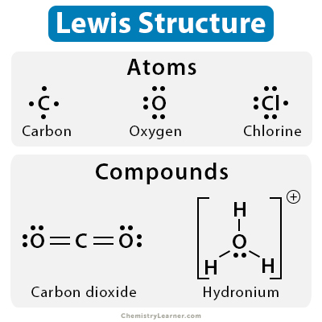

8.1 Lewis Symbols and the Octet Rule

* octet rule: all electrons tend to have 8 electrons in the outermost shell (stable octet)
  + attained through losing, gaining, or sharing electrons
* lewis symbol: an element’s chemical symbol with a dot for each valence electron

8.2 Ionic Bonds

* ionic bond: attraction between cations and anions
  + usually metals and nonmetals, i.e. NaCl (Na+Cl-)
* elements with low electronegativity (metals, H) tend to form cations
  + lose electrons because number valence electrons is a lot less than 8
  + usually exothermic
* elements with high electronegativity (nonmetals) tend to form anions
  + charge of monoatomic anion = |8 - number of electrons|
  + exothermic process
* representative elements (Mg, Al, etc.): charge of ion = number of valence electrons (group number)
* transition elements (Cr, Fe): various elements with different charges, reference the packet
* 1B to 4A periods 4-6: pseudo-noble gas notation, relatively stable
* structure of ionic compounds
  + do not exist as discrete units but as collections of charged ions in patterns
  + formula unit: lowest whole number ration of ions in an ionic compound (chemical formula)
* properties of ionic compounds
  + high melting point and hardness, brittle
  + do not conduct electricity as solids, but conduct well when molten or aqueous
* lattice energy: energy required to completely separate one mole of a solid ionic compound into its gaseous ions
  + used to measure strength of ionic bond
  + governed by ionic charges and radius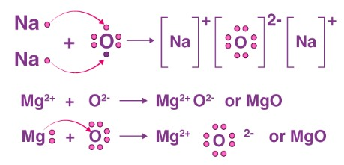

8.3 Covalent Bonding

* covalent bond: the electrostatic attraction force between sharing electrons and nucleus
  + formed by sharing of valence electrons
  + occurs between atoms that have high electronegativity
* if electronegativity difference < 2.0, covalent bonding occurs
* single covalent bonds: H2, N2, O2, etc. diatomic elements
* triple > double > single bonds for strength
* single > double > triple bonds for length
* bond disassociation energy: energy needed to break 1 mole of bonds
  + correlated with strength
  + H2(g) —> 2H(g)
  + breaking of bond is an endothermic process
* atoms form longer bonds going down a group

|  | **Sigma Bonds** | **Pi Bonds** |
| --- | --- | --- |
| **orientation** | linear and head-on | parallel and sideways |
| **components (orbitals)** | s-s, s-p, p-p | p-p |
| **dense electron area** | along internuclear axis | above and below internuclear axis |
| **rotation** | yes | no |
| **strength** | stronger | weaker |
| **bonds** | 1 in single, double, and triple bonds | 0 in single bonds, 1 in double, 2 in triple |

examples: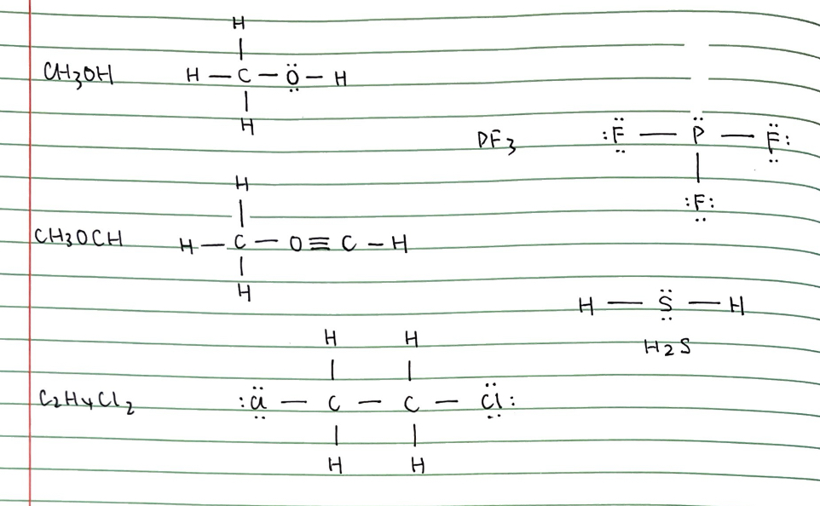

electron dot structure: only dots

structural formula: bonds as lines and dots

* + > more stable —> less potential energy
* chemical bond: the electrostatic attraction force that holds two atoms together

8.1 Lewis Symbols and the Octet Rule

* octet rule: all electrons tend to have 8 electrons in the outermost shell (stable octet)
  + attained through losing, gaining, or sharing electrons
* lewis symbol: an element’s chemical symbol with a dot for each valence electron

8.2 Ionic Bonds

* ionic bond: attraction between cations and anions
  + usually metals and nonmetals, i.e. NaCl (Na+Cl-)
* elements with low electronegativity (metals, H) tend to form cations
  + lose electrons because number valence electrons is a lot less than 8
  + usually exothermic
* elements with high electronegativity (nonmetals) tend to form anions
  + charge of monoatomic anion = |8 - number of electrons|
  + exothermic process
* representative elements (Mg, Al, etc.): charge of ion = number of valence electrons (group number)
* transition elements (Cr, Fe): various elements with different charges, reference the packet
* 1B to 4A periods 4-6: pseudo-noble gas notation, relatively stable
* structure of ionic compounds
  + do not exist as discrete units but as collections of charged ions in patterns
  + formula unit: lowest whole number ration of ions in an ionic compound (chemical formula)
* properties of ionic compounds
  + high melting point and hardness, brittle
  + do not conduct electricity as solids, but conduct well when molten or aqueous
* lattice energy: energy required to completely separate one mole of a solid ionic compound into its gaseous ions
  + used to measure strength of ionic bond
  + governed by ionic charges and radius

8.3 Covalent Bonding

* covalent bond: the electrostatic attraction force between sharing electrons and nucleus
  + formed by sharing of valence electrons
  + occurs between atoms that have high electronegativity
* if electronegativity difference < 2.0, covalent bonding occurs
* single covalent bonds: H2, N2, O2, etc. diatomic elements
* triple > double > single bonds for strength
* single > double > triple bonds for length
* bond disassociation energy: energy needed to break 1 mole of bonds
  + correlated with strength
  + H2(g) —> 2H(g)
  + breaking of bond is an endothermic process
* atoms form longer bonds going down a group

|  | Sigma Bonds | Pi Bonds |
| --- | --- | --- |
| orientation | linear and head-on | parallel and sideways |
| components (orbitals) | s-s, s-p, p-p | p-p |
| dense electron area | along internuclear axis | above and below internuclear axis |
| rotation | yes | no |
| strength | stronger | weaker |
| bonds | 1 in single, double, and triple bonds | 0 in single bonds, 1 in double, 2 in triple |

examples:

electron dot structure: only dots

structural formula: bonds as lines and dots